**Mariam’s Kitchen – Google Analytics**

3/25/2022

VERSION 0.1

1. **General dashboard. Access it via** <https://analytics.google.com/analytics/web/#/p308251011/reports/reportinghub>

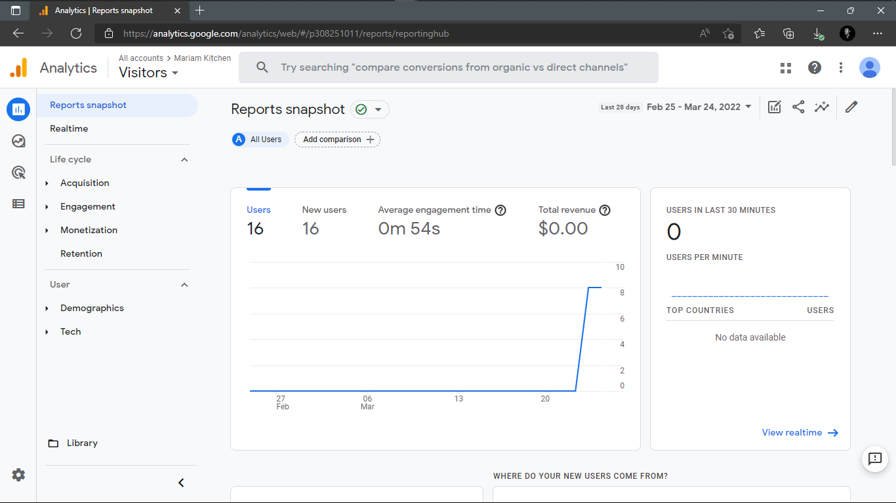

# **Report snapshot of visitors**

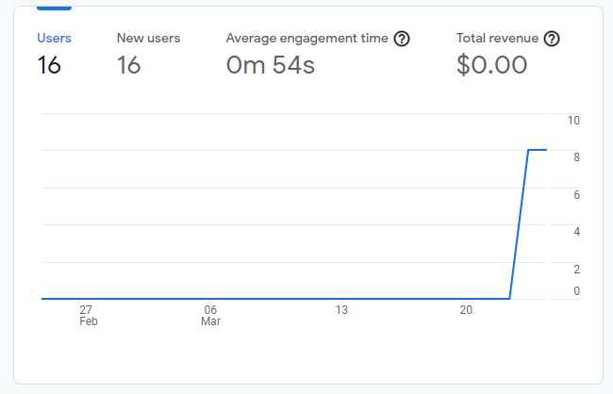

# **Users in last 30 minutes**

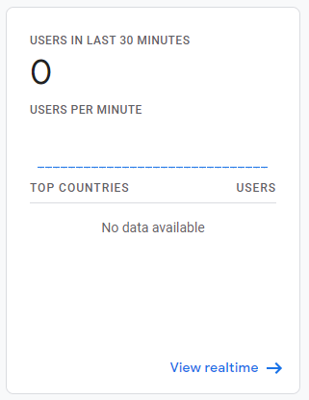

# **Source of traffic**

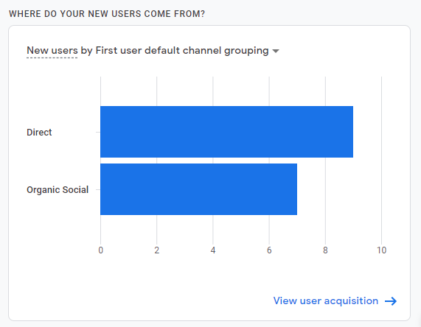

# **Traffic analysis by country**

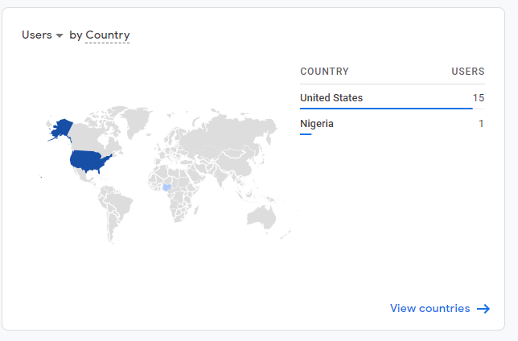

# **How are active users trending?**

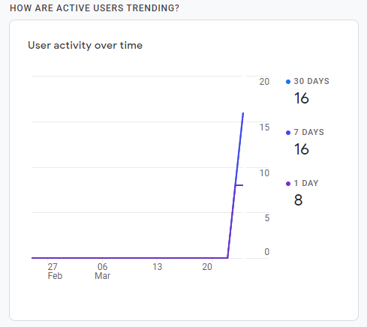

# **User retention analysis**

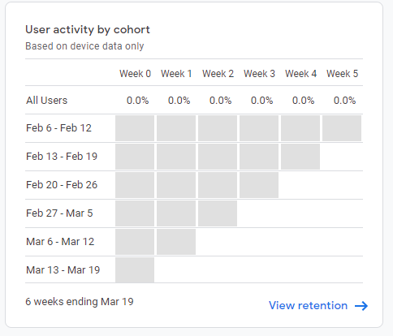

# **Analysis of page views**

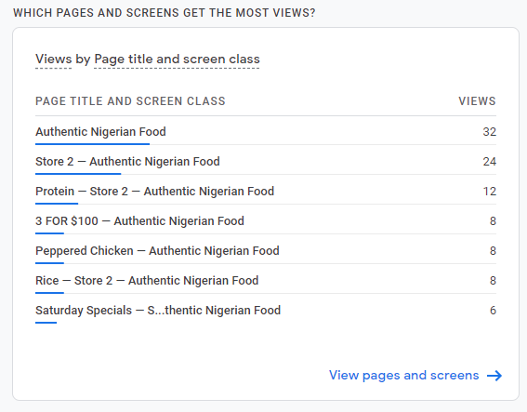

# **What are users doing on your website**

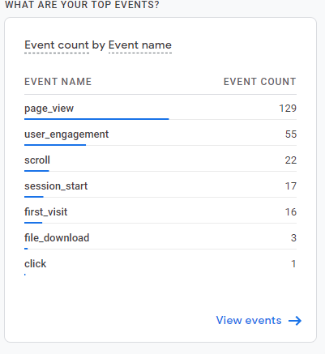

# **Platform comparison with others**

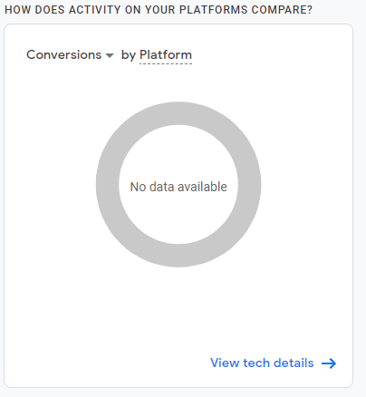

# **How are users visiting your website?**

